

**FACULTY OF ECONOMICS AND ADMINISTRATION**

**EIA2004 CRITICAL THINKING IN ECONOMICS**

**SEMESTER 2 SESSION 2020/2021**

**FINAL REPORT**

**IMPACT OF THE GLOBAL PANDEMIC**

**PREPARED FOR:**

**DR. GOH LIM THYE**

**PREPARED BY:**

**SULAM TEAM C**

**SUBMISSION DATE:**

**23th JUNE 2021**

**LIST OF TEAM C MEMBERS**

|  |  |
| --- | --- |
| **Name** | **Matric’s Numbers** |
| Dhiya Nur Zaheen Binti Muhammad Zailani | 17088786/EIA180029 |
| Emielda Azureen Binti Khairul Anwar | 17161693/EIA180032 |
| Goh Tze Xin | 17126208/EIA180040 |
| Jane Wong Huey Yuen | 17205288/EIA190044 |
| Laalitha A/P Raveenthar | 17120645/EIA180062 |
| Liang Yin | 17100330/EIA180713 |
| Muhammad Ashraf Bin Nor Azmi | 17096293/EIA170091 |
| Mohd Syafiq Syazani Bin Razmi | 17097445/EIA180083 |
| Saktira A/P Ravichandran | 17206840/EIA190152 |
| Shamita Linganathan | 17108836/EIA180155 |
| Xiong Ming Wei | 17133679/EIA170720 |
| Yuhanif Binti Ismail | 17099647/EIA180188 |
| Zhu Zhi Zhou | 17104139/EIA180708 |

**TABLE OF CONTENTS**

1.0 INTRODUCTION AND PROJECT BACKGROUND 1

2.0 COMMUNITY DESCRIPTION 2

3.0 OBJECTIVES 2

4.0 IMPLEMENTATION 2

6.0 WORK SCHEDULE 10

7.0 MARKETING/ADVERTISEMENT STRATEGY 11

8.0 BENEFITS OF THE PROJECT 14

9.0 CHALLENGES 16

10.0 RESULT OF SURVEY 18

11.0 ACHIEVEMENTS/IMPACTS 22

13.0 CONCLUSION 23

# INTRODUCTION AND PROJECT BACKGROUND

This project is a webinar with the simple aim of educating the participants on the impact of the global pandemic and providing a world view on it. Apart from that, this webinar also aims to help provide more info to those who would like to pursue their Bachelor’s in Economics. These are essentially the essence of the entire programme organised by us.

Given the pandemic situation, it was found that many STPM and pre-university leavers faced a lack of clarity in terms of figuring out their next steps. Hence, in order to overcome this issue, we decided to provide them with firsthand experience on the options that are available to them.

Before getting into that aspect of it, we had also presented the impact of the pandemic. There were 2 main reasons for getting into that aspect. The first reason is to obviously shed light on the lesser-known facts but the second reason is to teach them how economic research is done and that it is largely based on facts.

The idea of this came about during one of our brainstorming sessions where we were trying to think of doing something that would add value to the members of society. In order to create an impact, we knew that we all had to work hard and synthesis proper data in order to really help them.

# 2.0 COMMUNITY DESCRIPTION

We aimed to target the pre-university students in order to shed light on some pressing concerns that they had. We have all been in that situation where we were very conflicted by things. Hence, we chose students from different pre-university programmes and approached them but we had more people from STPM who attended this event.

Apart from that, there were also some university students who attended this programme to gain an insight on the pandemic and how it has globally affected us all.

# 3.0 OBJECTIVES

We have 3 objectives that wanted to be achieved for our SULAM project. Those are as following belows:

1. To create awareness on the impact of Covid-19.
2. To encourage students to express their ideas and comments on the global pandemic
3. To expose students to the Economics programme in UM.

# 4.0 IMPLEMENTATION

Our project goals are as following belows

1. To help the students who attend the webinar gain an insight regarding the courses in the Faculty of Economics & Administration University of Malaya.
2. To introduce the impact of Covid-19 on the world economy from five different aspects including businesses, households, online economy, employment and increased inequalities, and answer other questions from students.
3. To explain the impact of Covid-19 on the Malaysia economy and the appropriate measures taken by the government to respond to the pandemic, and answer other questions from students.
4. To help students get an exposure on the current issue especially regarding the impact of the pandemic on both the world and Malaysian economy.
5. To help students with a better understanding towards the procedure of  applying for the Bachelor of Economics at the University of Malaya.

**Target registration goals:** To gain at least 50 respondents for booking webinars have been received in the registration questionnaire.

**Target attendance goals:** To gain at least 50 participants that attend the webinar.

**Real-time feedback goals:** To get at least three people who participate in the Q&A session and share their question during the webinar.

**Post-event goals:** To get information on at least 30 participant’s knowledge on the topic of discussion after the webinar by sending the post-feedback questionnaire.

**TASK ALLOCATION**

|  |  |
| --- | --- |
| **Task** | **Person in charge (PIC)** |
| **Slide presentation**   * Prepare an adequate PowerPoint presentation. * Make the slides presentable and readable. * Speaker shall decide the topic of discussion and inform the group. (Suggestion: Shamita – Malaysian economy, Jane – World economy and Saktira – Introduction of UM courses). * Speaker should decide among themselves about the turn for the presentation.   Due date: 18th April 2021, 12PM | Shamita  Saktira  Jane |
| **Pre-feedback and post-feedback form**   * This form is intended to get information on participant’s knowledge on the topic of discussion before and after the webinar. * The PIC should liaise with speakers to get appropriate information to set up the questions. * Use the same form and distribute it before webinar then after webinar (by QR code or link, shall be decided by PIC). * The data obtained can help us to measure the effectiveness of our webinar and eventually help us to write the report. * The PIC may decide what platform to set up the form, such as Google Form or any other platform that the PIC finds suitable.   Due date: 18th April 2021, 12PM | Yuhanif |
| **Poster**   * Design a poster to introduce our speakers, main topic, time, date, or any important information that PIC finds suitable. * Please include a decent photo of the speaker and denote the topic of their presentation in the poster. * Make sure the poster is presentable and professional. * The PIC may take another webinar poster and use it as an example, just to get a better picture on how a webinar poster should look like.    Due date: 18th April 2021, 12PM | Liang Yin |
| **Tentative**   * Prepare the webinar tentative and include all important timing that must be followed by our team and the participants. * For example, all participants should join the webinar at 9:30am to avoid any technical problem, the technical team should enter the webinar and play an introductory music before the webinar starts, etc.) * The PIC should find any relevant information to see how a proper and professional tentative should look like. * There are 4 slots overall and each slot is 15 minutes each.   Due date: 18th April 2021, 12PM | Emielda |
| **Proposal preparation, webinar moderator and PR**   * This proposal is for formality and requested by the school. * It includes the objective of this webinar, justification and how it helps the participants. * Become the spokesperson to represent the team and mediate the information. * Manage all contacts related to the project. * Become the moderator during the webinar.   Due date: 16th April 2021, 12PM | Ashraf |
| **Data collection form**   * This is different from the feedback form and will be distributed on 18th April 2021 hence the form should be prepared before the distribution date. * The form is intended to obtain the information of the participants such as full name, IC number, email, phone number and any relevant information. * Email and phone number are compulsory, other information can be included if the PIC finds it suitable. * Can set it up using Google Form as it is convenient.    Due date: 17th April 2021, 12PM | Laalitha |
| **Certificate preparation**   * This is one of the most crucial things as it is the things that attract participants to join. * Please contact the dean’s office to get information regarding how to obtain the dean’s signature for this certificate. * The design for this certificate shall be prepared by the PIC and task allocation should be decided among PIC(s). * Please show the final design in the group. * After obtaining participant’s information, the PIC should start preparing the certificate. * There are three deadlines that the PIC should follow.    Due date for getting the procedure: 16th April 2021, 11:59PM  Due date for final design: 21st April 2021, 12PM  Due date for certificate preparation (46 participants): 23rd May 2021, 12pm | Dhiya  Xiong Mingwei  Zhu Zhi Zhou |
| **Technical preparations**   * Technical teams usually execute their task during the webinar, however there are several tasks that shall be prepared to avoid any problems during the webinar. * Prepare the link for Google Meet and post the link in our group one day before the webinar starts. * Prepare a standardized poster that can be used as a background by the speakers during their presentation. * Prepare decent music and play it from 9:40am until 10am. * Make sure the presenter’s first slide is viewable while waiting for all participants to join. * All members must join the Google Meet at 9:30am to avoid any technical problems.    Due date for standardized poster: 18th April 2021, 12PM | Syafiq  Goh Tze Xin |

|  |
| --- |
| **IMPLEMENTATION SCHEDULE** |
| 13 April 2021  Meeting with Penolong Kanan Tingkatan Enam SMK Dato’ Kamaruddin, Batu Kurau, Perak   * Our spokesperson was instructed to have a physical meeting with the teacher in SMK Dato’ Kamaruddin, Batu Kurau, Perak to discuss in detail about the webinar. * The discussion was held for 1 hour and there were two STPM teachers who were involved in the meeting. * Our spokesperson reached an agreement with the teachers to allow their students to participate in the webinar virtually. * The students who are involved have a general understanding and knowledge about the topic that will be discussed during the webinar. * We expect all students to get an exposure on the current issue especially regarding the impact of the pandemic on Malaysian economy. * The students will gain e-certificate and the teachers agreed to give them marks for their co-curriculum report. * The students also gain an insight regarding the courses in the Faculty of Economics & Administration University of Malaya. We hope this insight can help to increase their motivation to study well, get a good grade and pursue their studies after they finish their STPM period. |
| 14 April 2021 – 21 April 2021  Work Progression   * All members were given a task to be done before the webinar and they needed to adhere to the deadlines. * Adhering to the deadlines is crucial to avoid any hiccups in this webinar implementation. * Details on the task allocation are explained in the “Task Allocation” part. |
| 25 April 2021  The Webinar Day   * All team members get ready to login to Google Meet at 9:30am and the webinars start at 10:00am. An early preparation is important to avoid any technical issue during the webinar. * The agenda of the webinar are as follow: * 9:30am Participants Login * 9:50am Welcoming Remarks * 10:00am Slot 1: Covid-19 and The World Economy * 10:15am Slot 2: Covid-19 and Malaysian Economy * 10:30am Slot 3: Introduction to UM Programs * 10:45am Q&A Session * 10:55am Closing Remarks |
| 21 May 2021  E-Certificate Dissemination   * Our Person-In-Charge (PIC) disseminates e-certificate to all participants through Google Drive and shares the link in the WhatsApp group. |

# 6.0 WORK SCHEDULE

|  |  |  |  |  |  |  |  |  |
| --- | --- | --- | --- | --- | --- | --- | --- | --- |
| Activities | Apr 10 | Apr 13 | Apr 16 | Apr 17 | Apr 18 | Apr 21 | Apr 25 | May 21 |
| Brainstorming and Planning the event |  |  |  |  |  |  |  |  |
| Assign the speakers and Moderator |  |  |  |  |  |  |  |  |
| Contacting the STPM School for Participants |  |  |  |  |  |  |  |  |
| Proposal Preparation for school PIC contact |  |  |  |  |  |  |  |  |
| Procedure for certificate preparation |  |  |  |  |  |  |  |  |
| Data Collection form preparation |  |  |  |  |  |  |  |  |
| Distribution of Data collection form for participants |  |  |  |  |  |  |  |  |
| Prepare the slides presentation |  |  |  |  |  |  |  |  |
| Prepare the Pre-feedback and Post-feedback form |  |  |  |  |  |  |  |  |
| Prepare the poster and tentative |  |  |  |  |  |  |  |  |
| Finalized design for certificate |  |  |  |  |  |  |  |  |
| Webinar Day  Topic: **Impact of Covid-19 on world and Malaysian economy** |  |  |  |  |  |  |  |  |
| Distribution of e-certificate |  |  |  |  |  |  |  |  |

# 7.0 MARKETING/ADVERTISEMENT STRATEGY

We have used 3 ways to advertise our webinar’s project to targeting groups which includes Facebook, meeting face-to-face with headmaster of school and poster dissemination. For STPM student, we approached them in 2 ways which are virtual communication and physical communication. For virtual communication as you can see Figure 1-2, we used facebook as our platform to seek approval from them for our webinar which we sent our webinar registration form which include the link to our webinar. For physical communication, we met the headmaster directly in order to seek approval for our webinar. Meanwhile for UM students, we spread the poster of our webinar through whatsapps which we included the QR code in that poster(See Figure 4) in order for them to register

* 1. **Facebook**

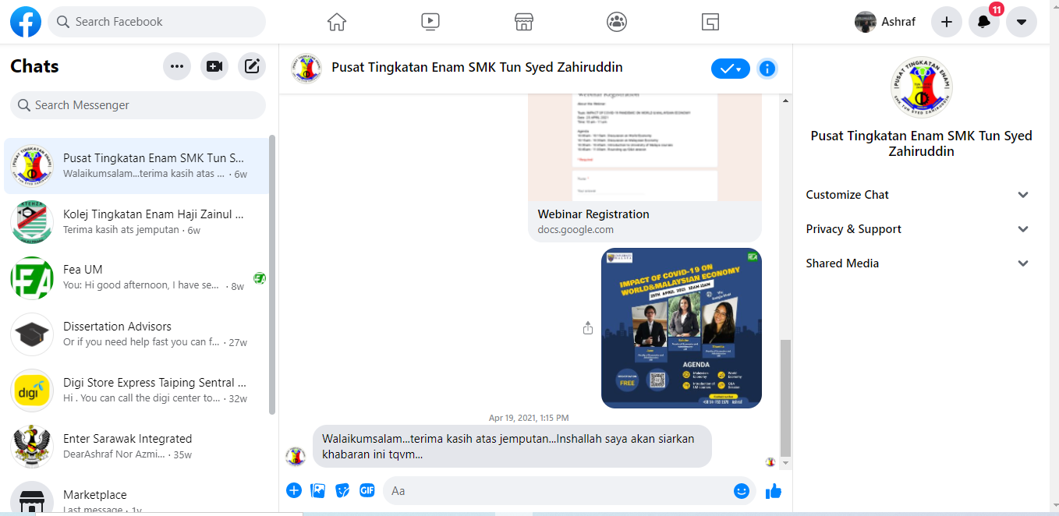

*Figure1 : Form 6 College Centre SMK Tun Syed Zahiruddin*

*Figure 2: Form 6 College Haji Zainul Abidin*

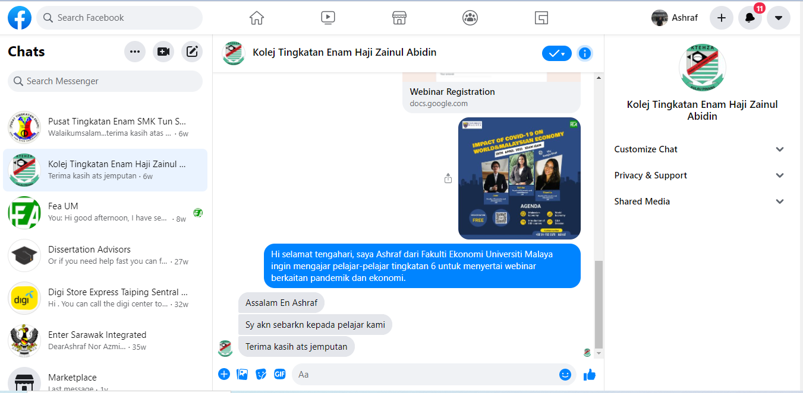

**\**

* 1. **Direct communication with the headmaster of school**

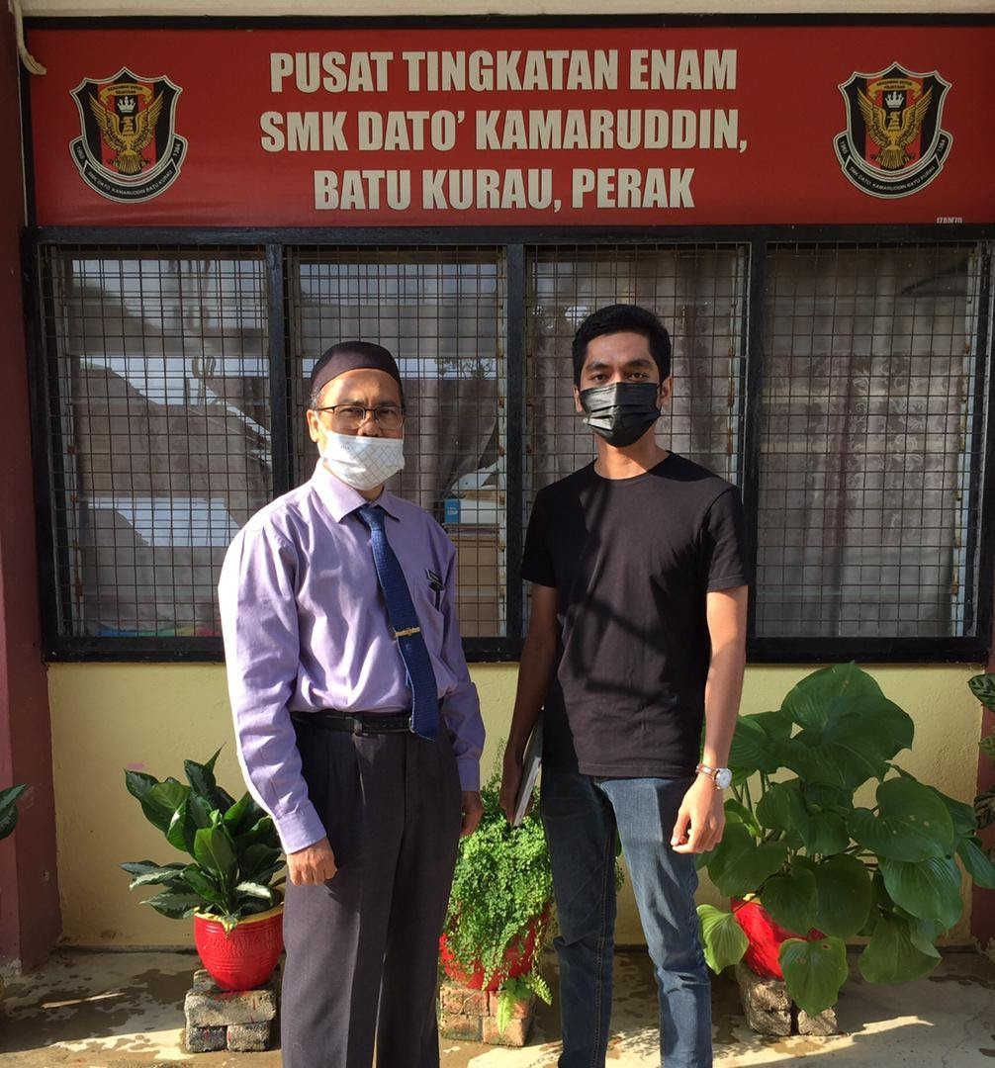

*Figure 3: Face-to-face meeting with headmaster of Form 6 College SMK Dato Kamaruddin Batu Kurau, Perak*

* 1. **Whatsapp**

1. **Poster of Webinar**

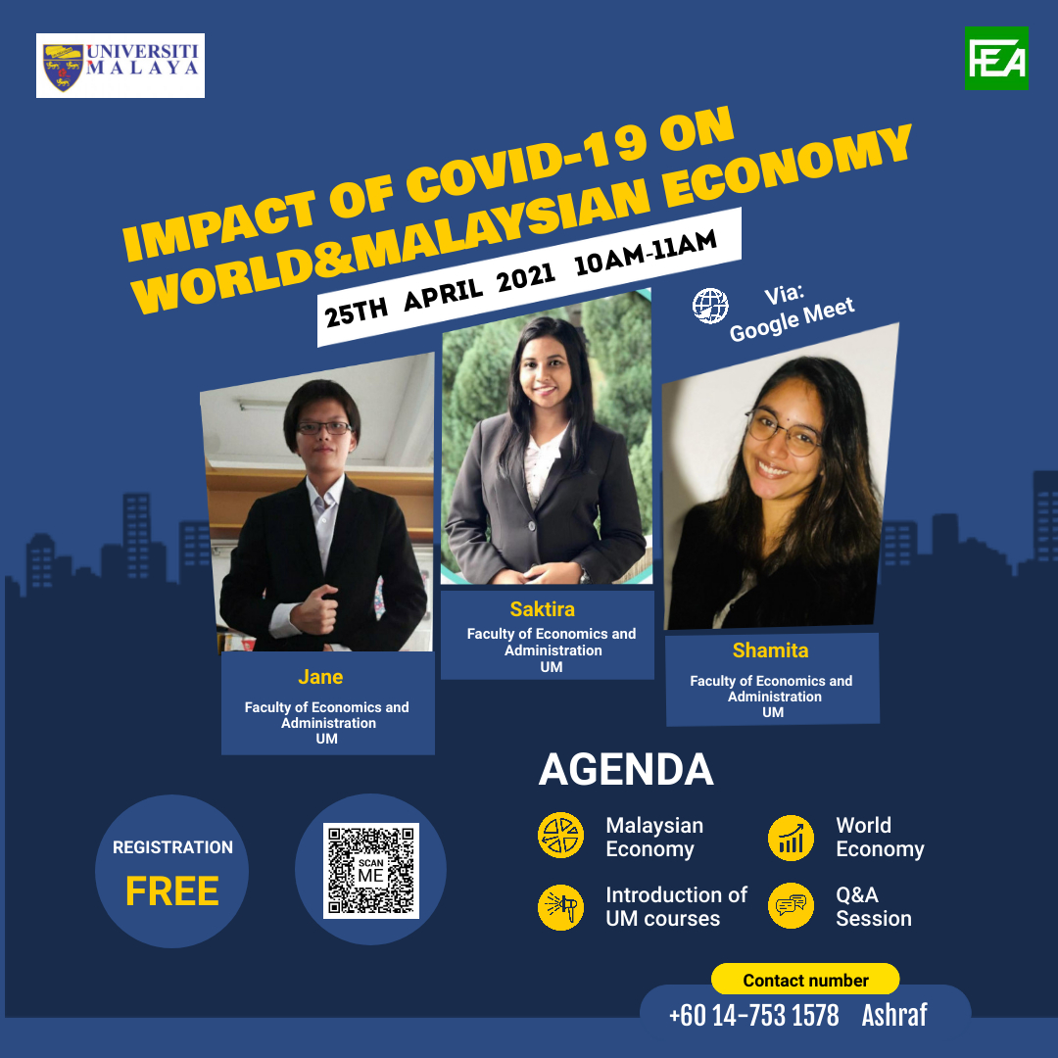

*Figure 4: Poster background of Webinar*

# 8.0 BENEFITS OF THE PROJECT

In this section, we want to talk about our expected benefit that we hope to see in the future not to only participant who joined the webinar but also to government or policy maker as well. This is important for us to make sure our SULAM project become fully successful and also important for our decision making on future research project. However, we are going to focus more on students, public and government and we expected that they will gain benefit from this webinar.

1. **Students**

Students are important assets to the country because some of them might become policy makers in the future. First, it is important to make sure they are well informed about the economy. So by doing this program we hope them they will gain a lot of knowledge about the economic and will help them to become economic decision maker. Not only that we will also want to give them a direction of their study so that could help further their study in university. In this webinar, we also provide the slot of bachelor of economic course in University of Malaya(UM) to them regarding the prospect of job and career that they can pursue in the future.

1. **Public**

The public here, it doesn’t only to refer to the participant but it also refer to non-participant who watch our pre-recorded webinar as well. The public is also important economic agent who contribute to the economy. Their decision are well affected the economy. Given the our current economic situation, it seems most of them are lack awareness on the impact of pandemic on global economy. They don’t even bother and concern about what happen to our worst economic condition right. Therefore, by doing this webinar, we hope that we can give them about basic knowledge so that they become more aware and give more concern to the economic conditions. Not only that, we also hope that it could their decision on the economy in future would become more better and will act proper and smart way in order to become more productive and sustained in facing the global pandemic.

1. **Governments**

Government is the most important actor who play role in-term of regulation and also keeping the economy in good condition. Good governance will ensure higher public well-being. For case of Malaysia, we could say that the Malaysia have quite poor performance of administration. For example MCO enforcement which is imposed by government of Malaysia in order to prevent COVID-19 is still at low level and quite loosen whereby there are some people who easily broke up the law in which there are still many people who still crossed the border even though it is forbidden by MCO laws. It seems that the government didn’t take serious to curb COVID-19 spread which it can give impact toward health of Malaysian citizen and also towards the economy. Therefore, knowing this problem, we hope that the government can gain benefit in-terms of higher efficiency of its regulation in order to curb COVID-19 cases effectively. Hence, government must take progressive action in order to produce the huge outcome in the future in solving the COVID-19 cases.

# 9.0 CHALLENGES

Our team faces numerous hurdles prior to and during the webinar. Even while webinars have many benefits for those looking to reach a large audience for a low cost, our team ran into several obstacles and obstacles when planning this webinar.

Not getting enough attendees. Initially, one of our team members, Ashraf, was able to recruit roughly 50 STPM students for our webinar through his secondary school instructor, but only 10 students registered on our webinar registration form the day before the webinar, resulting in a low attendance problem for our webinar. However, our team was able to handle and fix the situation by sending the registration form link to all pre-university and current degree students in order to obtain participation at the last minute. Finally, our team was able to gather roughly 50 people.

The next consideration is the dependability of the software or medium channel that our team will use to host the webinar. Initially, our team planned to host the webinar through Zoom because we believed Google Meet would be unable to record the webinar for more than an hour. The technical team then decided to use Apowersoft Screen Recorder, which is a new option. However, due to the differences between Mac and Windows operating systems, our team ultimately chose to use Google Meet, fearing that the participants would be unable to launch the apps during the webinar.

Some technical faults with webinars occur before the live broadcast even begins. It makes no difference how good or well-prepared the presentation is. One of our panelists lost connection and experienced a technical issue a few minutes before the webinar began. But, before the live broadcast, our panel was able to address the problem by using her phone instead of the laptop for the live presentation.

There is a lack of involvement. Our panels are going over each slide one by one. There is no interactivity and no engagement. Some attendees may have been hesitant to interact with our teams because they are largely pre-university students, and there were few questions from them after the presentation. A Q&A session should be included in every webinar. It's critical that we interact with our audience directly. "Now we have open the slot for questions," the host said, and then there was that horrible stillness. ‘No one?'

However, our team had prepared earlier for that part where our team gave the attendees the option to send in questions when they registered the form and invited them to ask questions again via chat box during the presentation, and some of the questions were read by our team host and asked the panel team to answer them, despite the fact that some of the questions were quite difficult to answer. Fortunately, our crew did not encounter any issues following the completion of our webinar.

Despite the fact that our team had several obstacles, we were able to handle them in a timely manner thanks to our team's collaboration and efficiency. We were able to complete this webinar successfully.

# 10.0 RESULT OF SURVEY

We have conducted a post-survey form to collect feedback and opinions about our webinar from the participants of our event. We have distributed the survey through the Google Meets chat-box before and during the QnA sessions. A total of 25 responses were received. Below are the analyses of the survey.

1. **Participants level of interest**

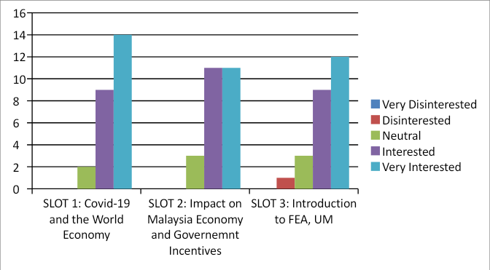

Figure 5: On the scale of 1-5 (1 being very disinterested and 5 being very interested), please share your level of interest for each topic that are being presented today.

Figure 5 compares the level of participant’s interest on each topic. Based on the result, only one participant rated disinterested for topic during slot 3 while majority of the participant rated very interested for all 3 slots, followed by the second highest rating of Interested. Overall, most participants have a very high interest on topic presented during slot 1, that is ‘Covid-19 and the World Economy’.  This data indicates that we have indeed managed to reach our goal of having high participant’s level of interest of the webinar.

1. **Usefulness of the information offered**

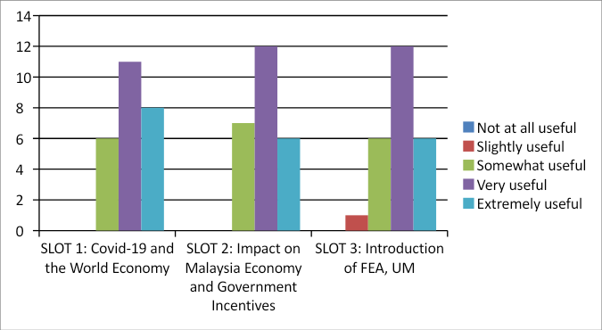

*Figure 6: How useful are the information from today's topic to you?*

The figure above compares the usefulness of the information presented on each slots. In terms of usefulness of the information presented for each slot, most participants rated very useful. For slot 3, only one participant founds the topic presented to only be slightly useful. By comparing the result for each slot, we found that on average; slot 1, according to the rating by participants, have the highest score on usefulness of the information offered. Based on the overall data shown in figure 2, it indicates a rather high percentage level of useful information being delivered.

1. **Topic relevancy**

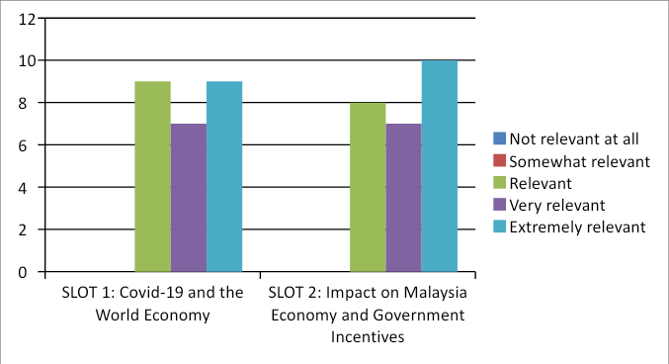

*Figure 7: How would you rate the level of relevance of today's session in a post pandemic world?*

In this section, we have only included slot 1 and slot 2 to be evaluated by the participants as topic for slot 3 have no relevancy on the main focus of our webinar, that is ‘Impact of Covid-19 Pandemic on World and Malaysia’. The number of participant that rates extremely relevant and relevant are equal at 9 participant each; in slot 1. In slot 2, a total of 10 participants rated the topic presented extremely useful which is also the highest rating in total. Overall, based on the result in figure above, on average, the highest rating on topic relevancy will be on extremely useful.

1. **Accuracy**

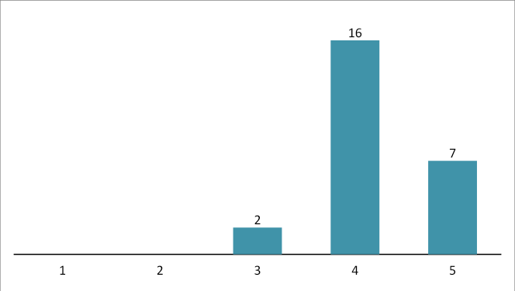

*Figure 8: How accurate was the session description as compared to the webinar?*

Figure 4 shows the amount of participants who founds the session description are in line with the webinar topic. Based on the result, on a scale of 1-5, 1 being inaccurate and 5 being very accurate, majority; 16 out of 25 participant, gives a rating of 4 indicating that the session description are indeed accurate. Additionally, 7 participants rate the webinar very accurate with the session description. Thus, it can be said that our goal to accurately meets the session description have been reached.

1. **Expectation**

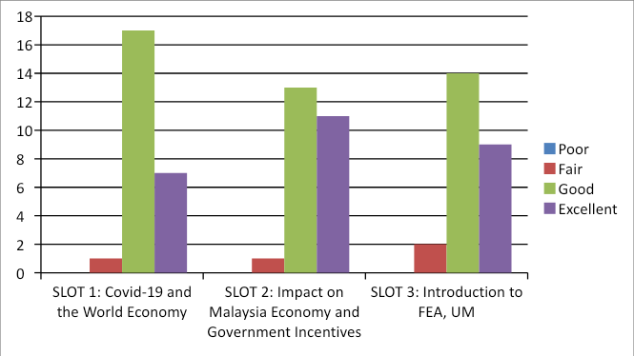

*Figure 9: How would you rate today's session compare to your expectations?*

On average, majority of the participants rated the expectation level as good followed by the second highest rate of excellent. None of the participant rates their expectation as being poorly met. All in all, based on the data from the survey form, it can be concluded that the participants of our webinar expectation has been met.

# 11.0 ACHIEVEMENTS/IMPACTS

Sulam is a webinar on "Impact of the COVID-19 pandemic on the Malaysian economy". Sulam’s objectives are STPM/ entrance exam students who are currently studying economics.We estimate there will be as many as 30 participants (the more the better).Anyone from the Sulam Group can be a spokesperson/panelist.By discussing this topic, we introduced participants to some of the impacts of COVID-19 on the Malaysian economy and indirectly promoted FEA UM.

To improve the social recognition and appeal of the faculty, size and quality is the key. And the number of students is an important aspect of measuring scale of higher education, to make faculty students to achieve a certain scale, form a good atmosphere of sustainable development.We hope that through our activities can make students more attention to the economic aspects of knowledge or social groups,and arouse students' interest in economics, because economy is closely related to our life.

The cumulative number of confirmed cases around the world is still rising. Maybe people have become numb to this number, but the fact is that the global epidemic is still unable to see the trend of turning point.An economic crisis is likely or is happening; a financial crisis is unlikely.But if the epidemic is not contained, there is still a risk of a global financial crisis, and it is fair to say that one wing of the black swan has not yet begun to flap.So we want to convey some economic information to the outside world to draw attention to some of the challenges that the Malaysian economy is facing and some of the policies of the government to deal with the COVID-19.By recognizing the economic aspects, it is hoped that people will also realize the importance of careful implementation of epidemic prevention measures and MCO.

The impact we hope to achieve is to increase participation in economic issues and awareness of the Malaysian economy during COVID-19, and to encourage students who are interested in economics or want to contribute to future economic research to join the Faculty of Economic and Administration.

# 13.0 CONCLUSION

The webinar was aimed to all of people without regard to their background they belong as we found most of them are lack awareness and not alert to what happen to our current situation of economy due to the widespread of COVID-19. Therefore, by doing this webinar, we can help enhancing their awareness on the impact of COVID-19 to the economy either regionally which include Malaysia itself or global economy so that it could help them to prepare better in economic decision in the future. Not only that, we also have another objective which is to expose them to the Economics programme in UM whereby we give some basic information about what type of economic courses that they can choose and how they can apply the courses later when they will enter UM. In-terms of cooperation and commitment, most of them include our group members have given their full of cooperation and commitment in ensuring our webinar become successfull as we can see that majority of them were able to come early into webinar. Thus, we hope the webinar that was conducted might give benefit to them in-term of giving the proper knowledge and helping them to become more aware with the devastated of the pandemic to the economy.