

**RHYTHM TO ECSTASY**

# KHIND STARFISH FOUNDATION PROJECT FOR HAPPINESS 2020

**ORGANIZED BY**

STUDENTS OF PIX2006

COMMUNITY SERVICE AND LEARNING IN MORAL EDUCATION

**LOCATION**

PURE LIFE SOCIETY, KUALA LUMPUR

**DATE OF PROJECT**

# 9TH NOVEMBER 2020 - 18TH DECEMBER 2020

## TABLE OF CONTENT

|  |  |  |
| --- | --- | --- |
|  | **Content** | **Page** |
| 1. | Introduction | 3 |
| 2. | Project Details | 4 |
| 3. | Organization Chart | 5 |
| 4. | Committee List | 6 |
| 5. | Project Timeline | 7 |
| 6. | Expenses | 8 |
| 7. | Appendix | 9 |

## 1.0 INTRODUCTION

As students who are majoring in teaching English as a second language and Early Childhood Education, with our experiences and prior knowledge, we want to run a service learning that can benefit not only limited to us but also for other people by exposing a variety of activities each session at the Pure Life Society. The major activity that we planned to run is the “Drama, Dances, and Poetry”. We chose to do these activities with them as it could serve as a bridge that will bring the relationship among the kids closer. Plus, these activities can be the stage for us to uncover the unpolished gems among the children in Pure Life Society. We hope that these projects will benefit greatly to the residents in this society. The Drama, Dance & Poetry performances that we are going to administer will involve the children in pure life directly. We planned to ensure that the kids will be learning how to act, dance and express themselves through poetry. Through these activities, we will teach the students on how to convey message using different techniques of acting, the basic moves of traditional dances and to write poetry according to theme. At the end of the day, they will gain knowledge and skills in the performing arts, it will help them present themselves confidently in public and able to opens their eyes to their own potential in the area.

## 2.0 OBJECTIVE

The main purpose while administering this community service program is to nurture the kids’ appreciation towards a different form of arts. The other goals were to assist the children to alleviate their stress while still having fun doing so.

1. To teach the children on how to act, dance and write poem.
2. To ensure the kids gain confidence towards the during their learning of performing arts.
3. To brush up on skills and the kids of Pure Life Society potential in performing arts.
4. To help the children relieve their stress during their session with us.

## 3.0 PROJECT NAME

“Rhythm to Ecstasy”

## 4.0 THEME

Culture

## 5.0 ORGANIZED BY

TESL and PAKK students of PIX2006 Community Service And Learning In Moral Education.

## 6.0 LOCATION

Pure Life Society, Wilayah Persekutuan Kuala Lumpur.

## 7.0 PERIOD

9th Novermber 2020 - 18th December 2020

## 8.0 TARGET

The children of Pure Life Society aged 7-17 years old.

## 9.0 ADVISOR

Prof. Dr. Vishalache A/P Balakrishnan

**10.0 ORGANIZATION CHART**

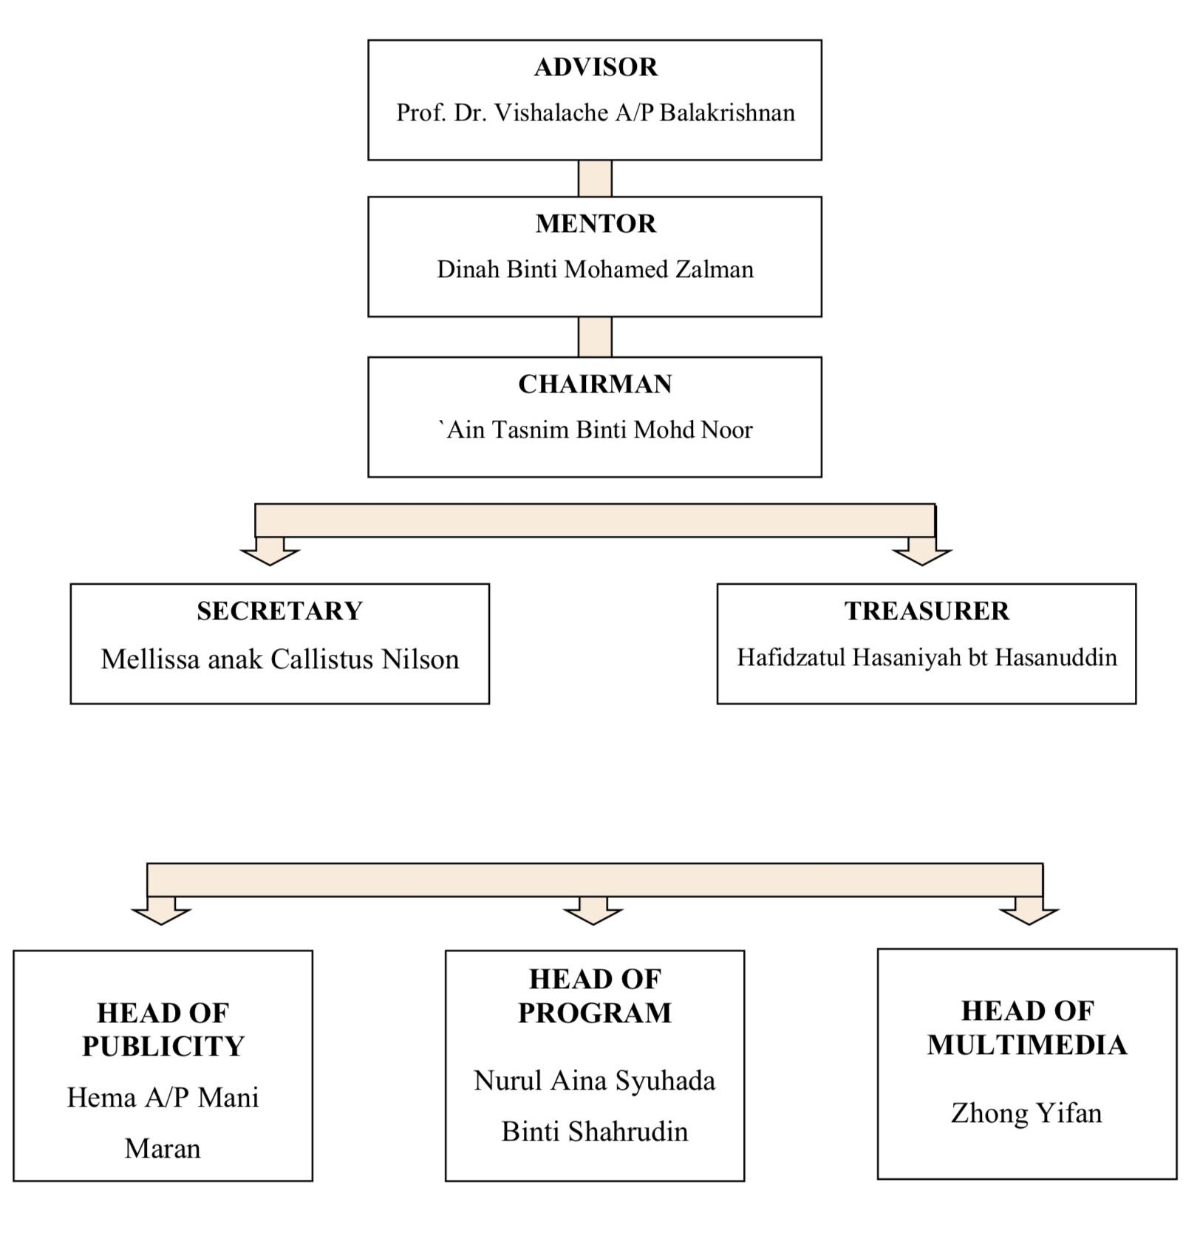

**11.0 COMMITTEE**

Introduction Session : `Ain Tasnim Binti Mohd Noor

Arts & crafts activity : 1. Hema A/P Mani Maran

2. Nilukshi Mahenthika Wijesinghe

Drama : 1. Nor Syakirin binti Mohd Husin

1. Aisyah bt Mohd Sofian
2. Nurul Aina Syuhada Binti Shahrudin
3. Xu Jiayue

Dance Activity : 1. 'Izzah binti Zamri

1. Angellica Guillan
2. Zhong Yifan
3. Mellissa anak Callistus Nilson

Poetry Activity : 1. Muhamad Akmal bin Ibrahim

1. Hafidzatul Hasaniyah bt Hasanuddin
2. Izzatul Madihah bt Mohamad Zailani
3. Khairulnisa Binti Mohd Yusof

## 12.0 PROJECT TIMELINE

|  |  |
| --- | --- |
| DATE | ACTIVITY |
| 20.10.2020 | * Project Committee Election via Whatsapp |
| 27.10.2020 | * Live Meeting via Google Meet   + Small group division   + Project proposal runthrough |
| 28.10.2020  -  02.11.2020 | * Brainstorming of Project Activities |
| 03.11.2020 | * Proposal presentation |
| 04.11.2020  -  09.11.2020 | * Crowdfunding |
| 10.11.2020 | * Discussion of video storyboard in small groups (Arts & Crafts, Drama, Poetry and Dance) |
| 21.11.2020 | * Introduction Session with Pure Life Society * Arts & Crafts Activity |
| 29.11.2020 | * Script review * General weekly meeting |
| 01.12.2020  -  20.12.2020 | * Improvement ad completion of Dance, Drama and Poetry Video |
| 03.01.2021 | * Dance Activity @Uncle Sam’s Kindergarten, China |
| 12.01.2021 | * Briefing for e-SULAM INNOVATE 2021 * Group reflection via Google Meet * Discussion for e-SULAM competition submission in small groups |
| 15.01.2021 | * MichelleXu kindy in china |
| 16.01.2021 | * Drama , Dance and Poetry Introduction Session with PLS Children * Video lesson presentation |
| 19.01.2021  - | * Completion of e-SULAM INNOVATE 2021 application |
| 29.01.2021 | * Nilu session in Sri Lanka |
| 05.02.2021  -  16.02.2021 | * Preparation of e-SULAM Booklet |
| 11.02.2021 | * Final Performance of Drama and Poetry by PLS Children |
| 21.02.2021 | * Final Performance of Dance by PLS Children |

**13.0 EXPENSES**

|  |  |  |  |
| --- | --- | --- | --- |
| **Project Expenses** | | | |
| **INCOME** | **BUDGET**  **RM** | **ACTUAL** | **NOTES** |
| **Monetary sponsorship from Khind Starfish** | **3,000** | **3,000** |  |
| **Monetary Sponsorship (crowdfunding)** | **1,000** | **1,045** |  |
| **Other sponsorship total income** | **NA** | **NA** |  |
| **TOTAL INCOME** | **4,000** | **4,045** |  |
| **EXPENSES** |  |  |  |
| **Drawing blocks** | **20** | **20** |  |
| **Oil pastel crayons** | **950** | **962** |  |
| **Tissues** | **30** | **30** |  |
| **Invoice postage** | **-** | **33** |  |
| **Total Crowdfunding** | **1,000** | **1,045** |  |
|  | | | |
| **Manila Cards** | **663** | **241.10** |  |
| **Eyeliners** | **20** | **20.61** |  |
| **Blue Plastic Bag** | **21** | **27** |  |
| **Cotton Wool** | **200** | **39.50** |  |
| **Black coloured paper** | **15** | **16.80** |  |
| **T-shirt (for dance activity)** | **60** | **58.66** |  |
| **Corsages** | **6** | **11.26** |  |
| **Kain Sarung** | **50** | **32.80** |  |
| **Poster** | **200** | **60** |  |
| **Postage** | **135** | **153.10** |  |
| **Postage Box** | **30** | **13.00** |  |
| **Pin boards** | **450** | **365** |  |
| **Certificate** | **-** | **24.80** |  |
| **Miscellaneous** | **138** | **42.85** |  |
| **EXPENSES** | **1,988** | **1,106.48** |  |
| **CROWDFUNDING** | **1,000** | **1,045** |  |
| **TOTAL EXPENSES** | **2,988** | **2,151.48** |  |
| **Surpluses/Deficits** | **1,012** | **1,893.52** |  |

**14.0 APPENDIX**

* Personal reflections (<https://drive.google.com/drive/folders/13bvmzjF38ocw93hDQTp_QP_yVs2wCVwp?usp=sharing>)
* Khind Report (<https://docs.google.com/file/d/1to730A9wRSRx3fzWby5YWoU_XdQi8WyF/edit?usp=docslist_api&filetype=msword>)
* E-Sulam Booklet (<https://docs.google.com/document/d/1Yw3dekcYgBICLcdpFIZbkD3ZrjGHvp6YuS0KsmYQy90/edit>)
* Project Media (<https://drive.google.com/folderview?id=1S4S5rBxo-HJNb6oXN7_v2sdIxn3wbcPM>)
* Project Members Namelist (<https://docs.google.com/spreadsheets/d/1e7HPy1mr1VY-FKImHTXCy4Ibypu9Lk847RN53VGdD-Q/edit?usp=sharing>)
* Khind Proposal (<https://docs.google.com/file/d/1mHKJTwcQlej1riWsdsIpcPj8e_fD7cAH/edit?usp=docslist_api&filetype=msword>)
* PLS Proposal (<https://drive.google.com/file/d/1tuwqy1Mke7pGdryAdym1kn_z_N1XP3O6/view?usp=drivesdk>)
* PLS Money Transfer Letter (<https://docs.google.com/file/d/1H45drAOmIYb_WXjyHB3MX6bFaJf1vtjM/edit?usp=docslist_api&filetype=msword>)
* Uncle Sam’s Kindergarten Visit Confirmation Letter (<https://drive.google.com/file/d/1twsQeRLDuH1Wpaayll7D6Gu6LU_WdrmA/view?usp=drivesdk>)